Buff willow- grown by Musgrove Willows

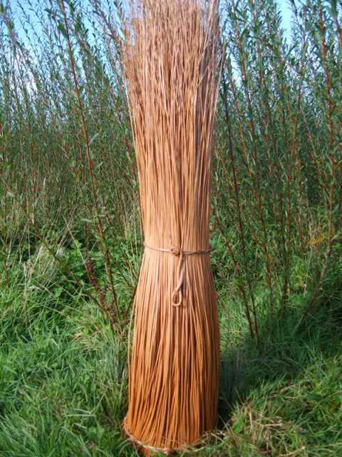
Buff willow also known as stripped willow.
This is most commonly the Black Maul variety, the best willow to use for this purpose. The natural barked willow is boiled in water for approx. 8 hours and the next day it is stripped of its bark and dried. The buff willow has to be soaked in water for about 11/2 hrs to make it more pliable for weaving. Black Maul, despite its name, is not black in colour.
We use 6ft and 7ft lengths of willow to weave the coffins. These rods are typically 6mm- 8mm thickness at the base of the willow rod tapering for the last 2ft of length.

